1. **Discuss the functional organization of hormones, their molecular structure and families.** 
   * **Steroid hormones**: made of cholesterol
     + glucocorticoids, mineralocorticoids, estrogens, progestins, androgens, vitamin D
     + signal through intranuclear signaling
   * **Thyroid hormones**: made of tyrosines put together
     + T3 and T4
     + signal through intranuclear signaling
   * **Amines**: small molecules, also neurotransmitters
     + epinephrine, norepinephrine, dopamine
     + signal through extracellular signaling
   * **Peptides**: larger molecules
     + insulin, GH, prolactin, EPO, somatostatin, ACTH, TSH, TRH, LH, FSH, HCG, glucagon, PTH, etc
     + signal through cytokine-receptor, GCPRs, insulin, etc
2. **Understand the properties and actions of hormones as endogenous drugs.** 
   * hormones signal through various mechanisms to affect gene expression: intranuclear, tyrosine kinases, cytokines, ion channels, GPCRs, dimerization, etc
3. **Appreciate that endocrine disorders are visible to a discerning clinical eye.** 
   * because hormones act to amplify signals, there can be significant clinical findings like hyperplasia of dorsal fat pad, goiter, central obesity, exophthalmos, etc
4. **Appreciate the potential of endocrine therapeutics.** 
   * endocrine therapies can have significant benefit for patients (reversing the things above)
5. **Recognize the importance of glucose homeostasis and understand how to diagnose hyperglycemia.** 
   * Normal - fasting glucose <100 mg/mL (2-hour glucose <140 mg/dL) A1c <5.7%
   * prediabetes - fasting 100-125, 2-hour 140-199, A1c 5.7-6.4%
   * Diabetes - fasting >126, 2-hour >200, A1c > 6.5%
6. **Explain the steps required to secrete insulin.** 
   * glucose comes in to **pancreatic beta cell** through GLUT2 → glucose used by metabolism **ATP** produced → ATP closes the Katp channel → **membrane depolarizes** → calcium is let into the cell → insulin gets released
7. **Describe the actions of insulin in the liver, adipose tissue, and muscle during feeding and fasting.** 
   * Insulin is secreted as “proinsulin” and a connecting peptide (known as c-peptide) is co-secreted.
   * Insulin ½ life is 4-5 minutes; c-peptide ½ life is ~30minutes.
     + Clinically, we measure c-peptide to evaluate remaining insulin secretory function in patients with diabetes mellitus.
8. **Describe the actions of glucagon in the liver, adipose tissue, and muscle during feeding and fasting.** 
   * During fed-state - no glucagon production
   * During fasted state (glucose-gone) - glucagon goes to liver, adipose, heart, pancreas, brain
     + catabolic effects in liver & fat (lipolysis, FAO, glycogenolysis)
     + glucose prioritized for heart & brain
9. **Recognize that multiple hormones regulate glucose. List hormones that lower glucose and those that increase glucose.** 
   * Lower glucose: insulin, incretins (GLP-1, GIP)
   * Increase glucose: glucagon, epinephrine, growth hormone, cortisol
10. **Describe how the body copes with prolonged starvation.** 
    * body loses fat to spare functional energy reserves, insulin drops, glucagon increases (glycogen only lasts for for 3 days, so giving glucagon at day 3 of fast would have no increase in blood glucose)
    * ↓Glucose output by the liver and ↓glucose utilization
    * ↑Ketogenesis and ↑ketone use by the body
    * Preservation of protein and ↓urea synthesis
11. **Discuss the actions of insulin and glucagon during starvation.** 
    * insulin decreases, glucagon increases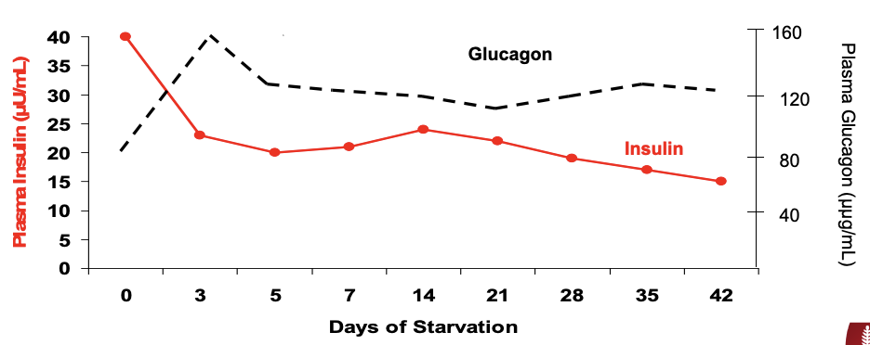
12. **Understand the clinical and laboratory changes that occur in diabetic ketoacidosis (DKA), a severe metabolic complication of insulin deficiency.** 
    * lack of insulin (no regulation), and high glucagon
    * hyperglycemia and **metabolic acidosis** occur
      + increased blood osmolality → makes you want to drink because you need to dilute the blood, but you are also excreting glucose in urine so you pee alot out and get volume depleted
    * SGLT2i drugs allow you to excrete more glucose, used initially for diabetes but is useful for heart failure too
    * DKA leads to **increased anion gap** (keto acids in blood)
    * **Treatment:** give fluids, give insulin, find and treat precipitating factor
13. **Recognize the similarities and differences between starvation and DKA.** 
    * insulin has deficient glucose not just down regulated
    * starvation → hypoglycemia vs. DKA → hyperglycemia
    * more ketone bodies with DKA
    * DKA reliably leads to dehydration & polydipsia (because hyperglycemia)
14. **Describe the differences between type 1 and type 2 diabetes.** 
    * type 1 - autoimmune destruction of beta cells, requires insulin, positive autoantibodies
      + to differentiate measure c-peptide, glucose, GAD autoantibody, other autoantibody
    * type 2 - insulin resistance, may require insulin in advanced stages
      + early type 2 can be reversed with exercise & diet
      + high fasting insulin indicates insulin resistance
      + DM2 is more heritable than DM1
15. **Describe the pathogenesis of type 1 diabetes: immunologic etiology, metabolic consequences.** 
    * Immune etiology
      + Combination of genetic background (HLA subtypes) and environmental triggers autoimmune attack on Beta cell which triggers insulitis, potentially triggered by viral infection
        - Stage 1 – presence of autoimmunity with normoglycemia
        - Stage 2 – presence of dysglycemia. No symptoms
        - Stage 3 – presence of symptoms + dysglycemia
      + there are different autoantibodies that are formed in T1D, but the type is not correlated with prognosis
      + 2+ positive autoantibodies has a 95% risk of developing T1D, any autoantibodies increases likelihood of needing insulin
    * Metabolic consequences
      + Long term complications: macro (CVD, peripheral arterial disease) & microvascular (retinopathy, nephropathy, neuropathy)
        - Neuro*genic* symptoms [either adrenergic or cholinergic mediated] include tremor, feelings of anxiety and or hunger and sweating
        - Neuro*glycopenic* symptoms [result of brain neuronal glucose deprivation]
      + ~3 month average of glucose can be checked with HbA1c
      + missed meal boluses (forgetting to take insulin when you eat) raises HbA1c
    * Must meet atleast 2 criteria for DM
      + Fasting blood sugar >126 mg/dL
      + Random blood glucose > 200 mg/dL with symptoms
      + 2 hr plasma glucose >200 mg/dL during a 75 gram OGTT
      + Hemoglobin A1c > 6.5%
16. **Discuss metabolic issues in the management of diabetic ketoacidosis.** 
    * Classic finding of DM is Polyuria, polydipsia, weight loss, hyperglycemia w/o acidosis
    * most common cause is insulin omission (teenagers forget insulin alot)
    * DKA criteria (must meet all 3)
      + Hyperglycemia – Plasma glucose >200 mg/dl
      + Metabolic acidosis – Venous pH < 7.30 and/or HCO3 <15 mmol/L
      + Ketonemia and ketonuria

|  |  |  |  |
| --- | --- | --- | --- |
|  | Mild DKA | Moderate DKA | Severe DKA |
| Plasma glucose mg/dL | >200 | >200 | >200 |
| pHvenous | <7.30 | <7.20 | <7.10 |
| Serum HCO3 mmol/L | <15 | <10 | <5 |
| Urine/serum ketones | +++ | +++ | +++ |
| Effective serum osmolality | Varies | Varies | Varies |
| Mental status | Alert | Alert/ drowsy | Stupor/ coma |

* + **Treatment goals**:
    - Correct dehydration, Correct acidosis and reverse ketosis, Correct metabolic abnormalities, Restore glucose to near normal, Avoid complications of therapy (cerebral edema if electrolytes are unbalanced), Identify and treat precipitating event
      * 1st 2 hours IV saline
      * then give IV normal insulin
  + Electrolyte imbalance: **K+ always depleted in DKA** (from vomiting & Katp pump)

1. **Recognize the use of a variety of exogenous insulins to manage patients with type 1 diabetes.** 
   * There are various types of basal insulin and bolus insulins that patients use - basal insulin is needed even if not eating – prevents DKA
   * Rapid acting: Lispro/Aspart/Glulisine
   * Short acting: Regular
   * Intermediate acting: NPH
   * Long acting: Glargine/Levemir/Degludec
   * Dosing: Calculate total daily dose (TDD): estimate 0.5 units per kg
     + Half of TDD given as “Basal” insulin
     + Half of TDD given as “Prandial” insulin
2. **Understand the definition and epidemiology of type 2 diabetes in adults.** 
   * 11% of US population has diabetes, 38% has pre-diabetes
   * higher prevalence in non-hispanic black and native americans
   * negative correlation with education
   * fasting glucose (FPG) above 120 causes retinopathy, so guidelines use FPG >100
     + normoglycemia: fasting glucose <100, 2 hr glucose < 140
     + impaired fasting glucose: FPG 100-123
     + impaired glucose tolerance: 2hr glu 140-199
     + DM: FPG > 126, 2hr glu >200, random glucose >200, HbA1c >6.5%
3. **Understand the pathophysiology of type 2 diabetes.** 
   * ⅔ of insulin signaling is from incretin hormones in the gut (difference between oral glucose and IV glucose)
     + There are two main incretins: GLP-1 (Secreted by L-cells in ileum and large intestine, Increases insulin, Decreases glucagon, Inhibits gastric emptying) & GIP (Less insulinogenic, From k-cells in foregut)
   * 85% of
   * resistance to insulin is not an receptor defect, but a “post-receptor” defect
   * glucose can be normal, but if TG>130 and TG/HDL ratio >3.0 serve as a marker of insulin
4. **Know the complications of type 2 diabetes.** 
   * when you present a diabetic patient say “55 yo pt with DM2 complicated by: peripheral neuropathy, retinopathy, nephropathy, MI, stroke, PAD” listing micro & macrovascular complication
   * **macrovascular changes happen first, when insulin is high**
     + MI, stroke, PAD
     + due to other factors too that are often present, HTN, dyslipidemia, procoagulant state, endothelial dysfunction, oxidative stress, inflammation, etc
   * **micro vascular changes are due to high glucose, later in disease when insulin resistance forms**
     + 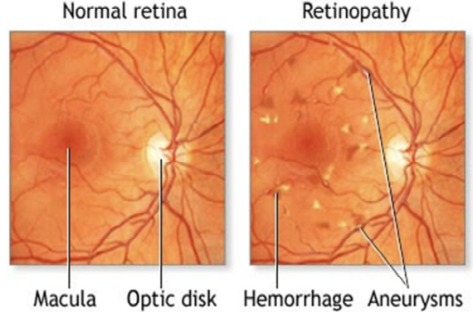Retinopathy: blood leaks in the retina due to high glycation end products and high ROS (diabetics should get frequent eye exams)
   * Lowering hemoglobin A1c (HbA1c) in type 1 diabetes is effective in reducing microvascular disease complications at expense of increasing risk of hypoglycemia
   * Diabetes is a cardiac risk factor! 7 yr risk of MI is 20%
     + for overweight diabetics metformin has a 39% reduction in MIs
   * every diabetic >40 should be on a statin or if LDL >190 (this is crazy high)
5. **Understand endogenous insulin synthesis and secretion.** 
   * endogenous insulin is a hexamer that is held together with zinc ion
   * c-peptide is cleaved off proinsulin to make insulin
     + c-peptide is more stable and is a better marker for distinguishing endogenous insulin levels than insulin itself
     + need to know glucose levels to understand c-peptide levels
   * 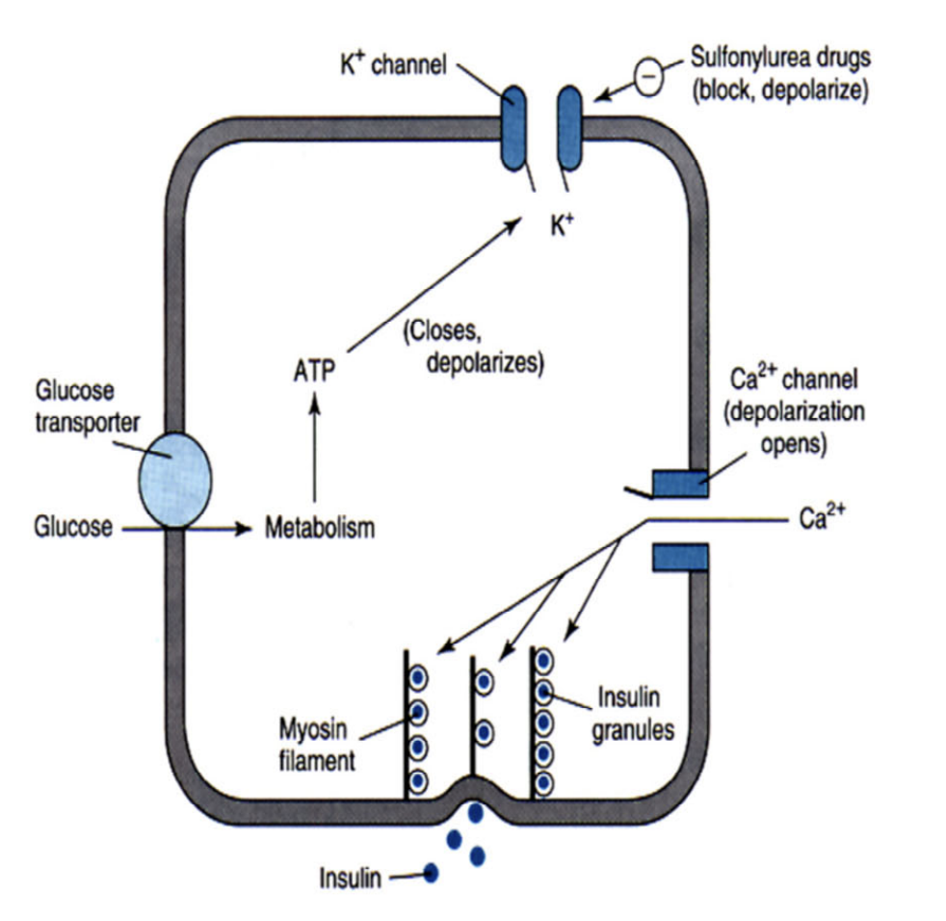
6. 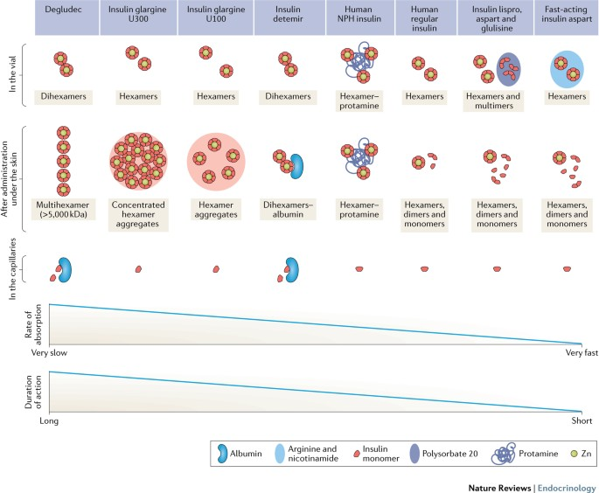**Understand several modification strategies to alter insulin action profile.** 
   * insulin with more sub-units will get used slower, you can further slow down insulin release by making it crystalize in vivo, adding protamine polymer, adding lipid tail, modifying it to stick to albumin
7. **Know the action profiles of insulin analogs and how to treat with insulin.** 
   * Insulin analogs
   * 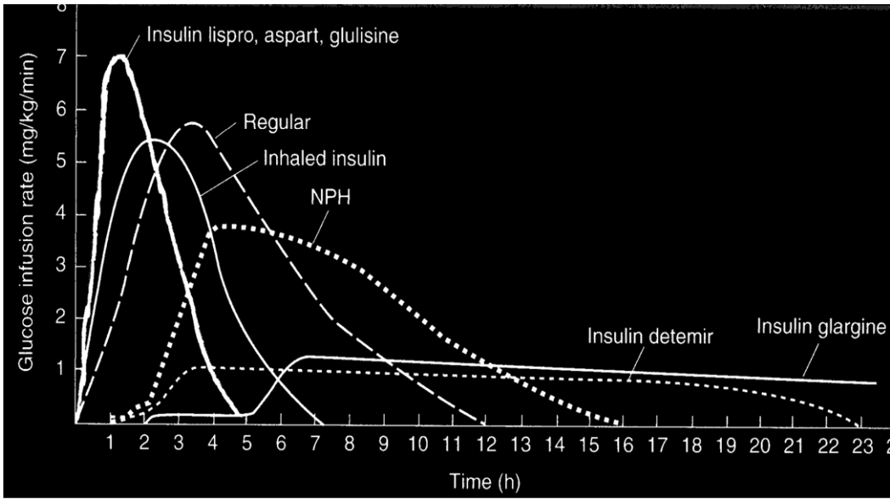
     + rapid acting (**g**irls **a**nd **l**ads): **g**lulisine, **a**spart, **l**ispro
       - onset 15 min, peak at 1-2 hr
       - use as prandial insulin
       - monomer units for rapid uptake
     + regular insulin
       - onset 30 min, peak at 2-3 hr
       - hexamer and some monomers
     + NPH insulin - used IV in hospital for DKA
       - onset 1.5 hr, peak 4-12 hr
     + long-acting “basal insulin”: detemir, glargine, degludec
       - onset 2-4, no peak, lasts 16-24 hr
   * **Intensive insulin therapy:**
     + half expected dose as basal insulin (glargine or degludec, or MPH) & prandial insulin
     + sliding scale insulin to tailor to individual based on live blood glucose
8. **Become familiar with various types of non-insulin therapies.** 
   * Metformin: first line diabetes therapy, Contraindication is kidney failure. Doesn't really affect insulin sensitivity/action. Primarily works on glucose production (gluconeogenesis) in liver
     + Decreased gastrointestinal glucose absorption, increased insulin sensitivity... and enhanced synthesis of GLP-1 may have minor roles
     + decreases MI risk in obese diabetics
   * Sulfonylureas and glinides: *\*insulin secretagogues\** block K+ channel on beta cell (as if glucose was present), causes depolarization, stimulates insulin excretion
     + 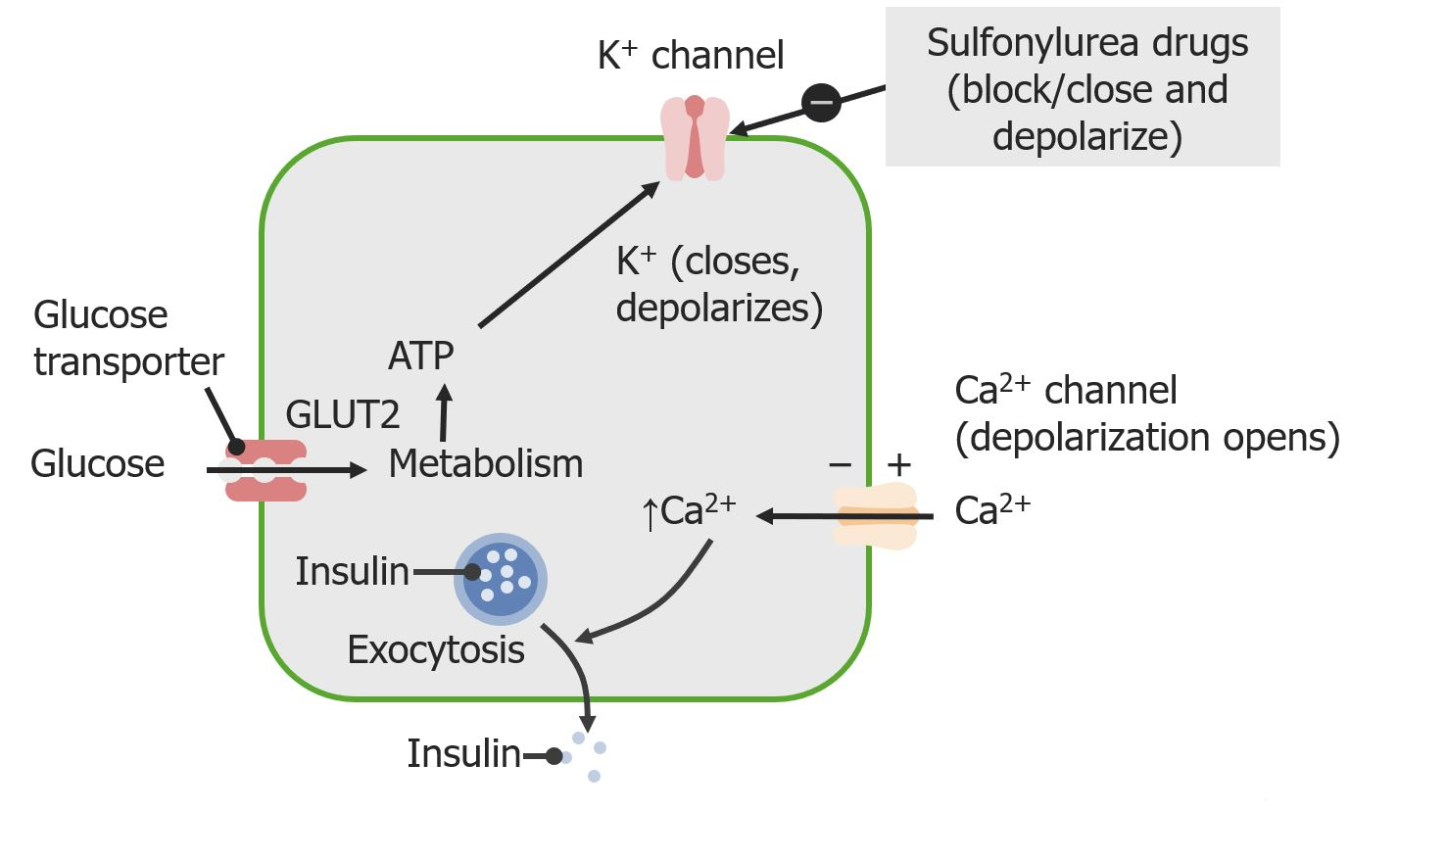
   * Thiazolidinediones (TZDs), also known as glitazones
     + get into fat cells and turn on transcription of genes related to weight gain. Cause redistribution of fat. Reverses lipotoxicity by moving fat away from the liver. But increases cardiovascular disease. Causes fluid retention and weight gain
   * GLP‐1: cause weight loss by causing satiety and slowed gastric emptying
     + decreases cardiovascular events
   * SGLT2i “flozins”(glucose flowz): prevent reabsorption of glucose from blood with SGLT2 transporters (90% of glucose). Cause glucosuria. Promotes weight loss. Insulin levels are low. Mimics starvation because you are peeing out glucose so body thinks it is starving
     + decrease cardiovascular events
   * AGIs (alpha‐glucosidase inhibitors): inhibit the conversion of oligosaccharides to monosaccharides at the intestinal brush border and thereby decrease the rise in plasma glucose concentrations after ingestion of complex carbohydrates
9. **Know the treatment goals for diabetes.** 
   * goal is HbA1c under 7%
   * avoid hyper & hypo glycemia
10. **To appreciate the potential of endocrine therapeutics**
    * Hypothalamus make **GHRH** → Stimulates pituitary to make **GH** → Stimulates liver to make **IGF-I** → stimulates growth plate to grow
    * T3/T4, E2/T, cortisol, nutrition also stimulate growth plate to grow
    * Hypothalamus also makes **Somatostatin** which negatively inhibits all of these pathways
    * 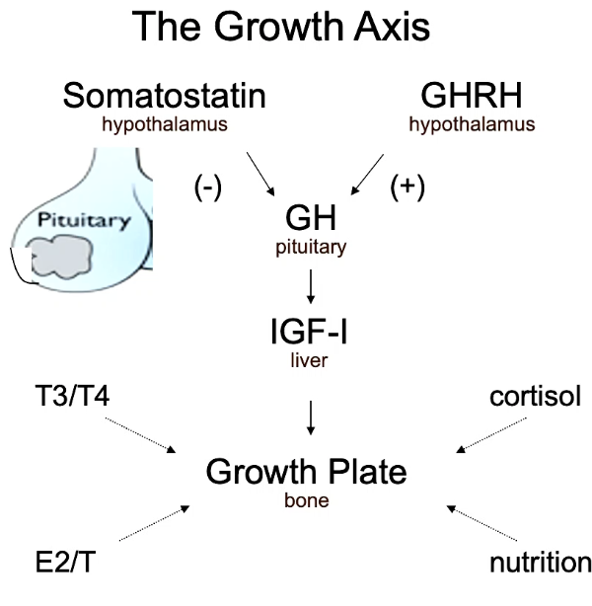
11. **Understand how polypeptide and catecholamine hormones are synthesized and inserted (“packaged”) into secretory granules for regulated secretion. Understand the importance of intracellular Ca++as the secretory “trigger”**
    * Protein & catecholamines hormones have some level of “constitutive secretion” along with “regulated secretion” that can be released on demand through exocytosis of secretory granules that are activated by free Ca++
    * Ca++ is the secretory signal
    * *Most of the protein & catecholamines hormone is waiting around in prepackaged secretory granules, ready to be released* ***in minutes***
    * 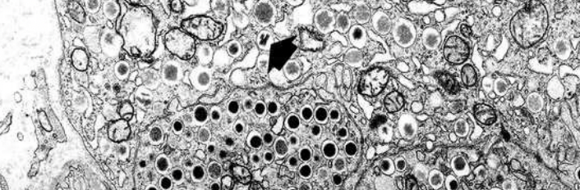
    * Secretory granules are approximately 30nm-1 um (remember human cell is like 5-10 um)
    * VAMP (vesicle associated membrane proteins) bind with SNARE proteins on the membrane and allows exocytosis [Dr. Südhof at stanford won a Nobel prize for this*]
12. **Understand differences in how steroid hormones are synthesized and secreted compared with polypeptide/catecholamine hormones**
    * Steroids are not stored in secretory vesicles like polypeptide/catecholamine
      + Steroids must be made on demand!
    * Endogenous steroid production has an effect in hours *not minutes like protein/epi
    * Ex: ACTH binds extracellular receptor → increased cholesterol uptake into the mitochondria & increases side chain cleavage of cholesterol in the mitochondrion
    * Steroids are lipophilic and can get into the cell (thyroid hormones require a transporter)
13. **Review secretion in the beta cell – a unique model of secretion regulated by a product of intermediary metabolism**
    * Insulin secretion is unique (doesn't quite fit standard protein hormone model because ATP levels cause membrane depolarization & then influx of Ca++ to release vesicles)
    * glucose is metabolized → closure of ATP dependant channel → membrane depolarizes → higher levels of Ca rush into cell → Ca++ is secretory signal for insulin release
      + Sulfonylureas are insulin secretagogues - help with the endogenous production of insulin secretion - by triggering K+ channel
14. **Understand general properties of nuclear hormone receptors**
    * Steroid hormones are made from cholesterol and are lipophilic which allows them to **enter the cell** (the thyroid hormones have a special transporter to get into the cell)
    * The receptors must dimerize to cause signal
      + the nonsteroid receptors are heterodimers
      + the steroid receptors are homodimers
15. **Understand how nuclear hormone receptors work**
    * Nuclear hormone receptors bind to hormone and initiate DNA transcription → gene expression
    * The nuclear receptors bind to “androgen response elements” on DNA which is a inverted repeat of 6 bps with 3 bp spacer (remember steroid hormones are homodimers)
    * 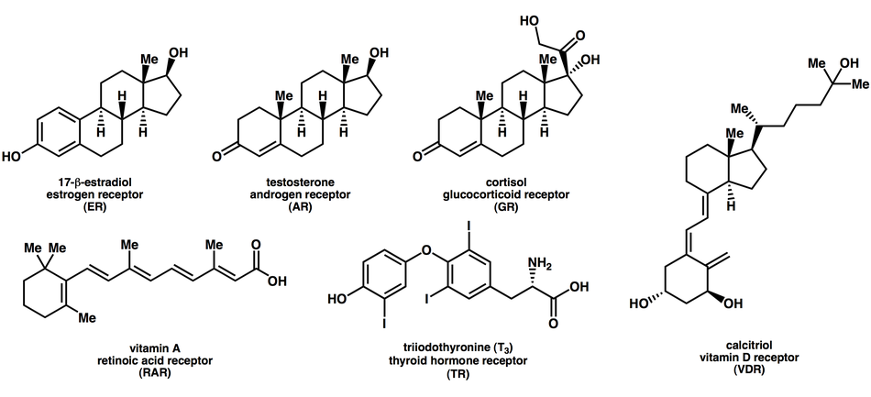
16. **Describe several therapeutic uses of specialized (selective) hormone receptor agonists and antagonists**
    * there are other co-activators & co- repressors that further modulate transcription signal
    * example: tamoxifen has agonist & antagonist effects in different tissues
17. **Understand examples in which abnormal hormone/receptor interactions can lead to human disease**
18. **Describe the comparative size and structure of lipoproteins; function of chylomicrons and VLDL particles to triglycerides and FFAs to tissues; function of lipoproteins to deliver cholesterol to tissues; function of HDL particles to reuptake cholesterol from tissues.**
    * Triglycerides are packaged in lipoproteins from the gut, chylomicrons are taken by the liver with APO-B48, FFA in liver are turned into VLDL with APO-B100 and put in bloodstream where cholesterol is released and VLDL reduced to IDL reduced to LDL → taken back to liver via LDL receptor
    * LDL is like a waste product
    * HDL - reuptake cholesterol from tissues
19. **Describe the function of the key apolipoproteins: B-48 and E for chylomicron remnan recognition and reuptake; B-100 for LDL-receptor recognition; CII for activation of lipoprotein lipase.**
    * Apo-B48: signature molecule for chylomicrons (exogenous lipoproteins) - chylomicron packaging
    * Apo-B100: signature molecule for VLDL (made endogenous by liver), the ligand for the LDL receptor,
      + *\*the key atherogenic molecule\**
      + On VLDL, IDL, and LDL (not chylomicrons)
    * Apo-E: mediate the binding of chylomicron remnants into liver
    * A-I: Activates LCAT, Receptor recognition
    * A-V: Binds LPL
    * B-100: Receptor recognition (LDL-Receptor)
    * C-II: Activates LPL
      + lipoprotein lipase (LPL), helps particles transfer triglycerides to the ones that need it
20. **Discuss endogenous (VLDL) and exogenous (chylomicron) lipid pathways.**
    * 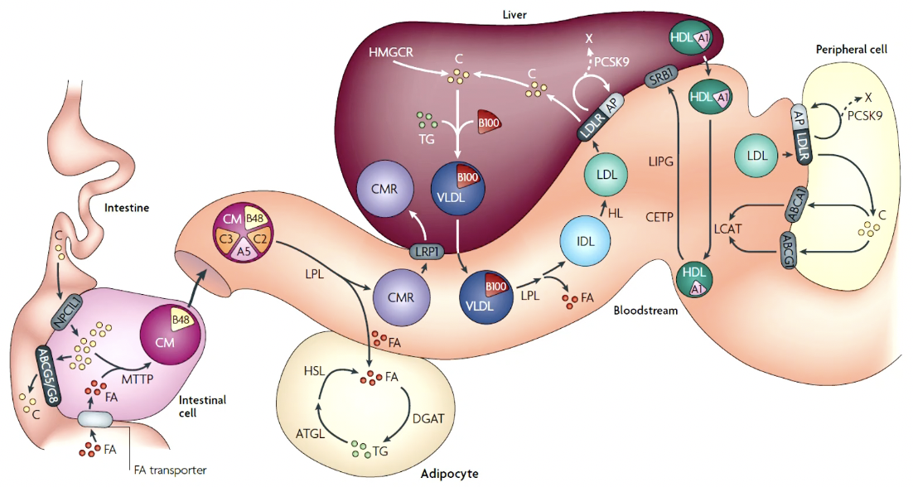
21. **Recognize different lipoprotein abnormalities and classifications of hyperlipidemia.**
    * **Clinical classifications of Hyperlipidemia**
      + **High cholesterol states** - defect in the ability to recycle LDL cholesterol
        - caused by some autosomal **dom**inant diseases (LDLR, APOB, PCSK9)
          * Most commonly caused by lifestyle
        - clinical findings: ↑↑ TC, ↑ LDL-C
        - tendon xanthomas, xanthelasma, corneal arcus, premature ASCVD
        - 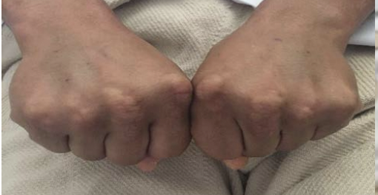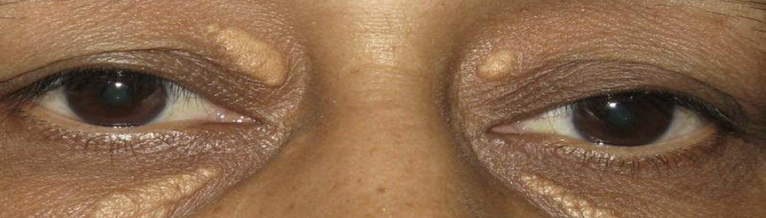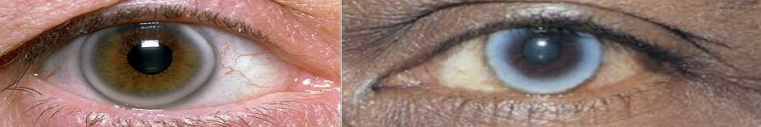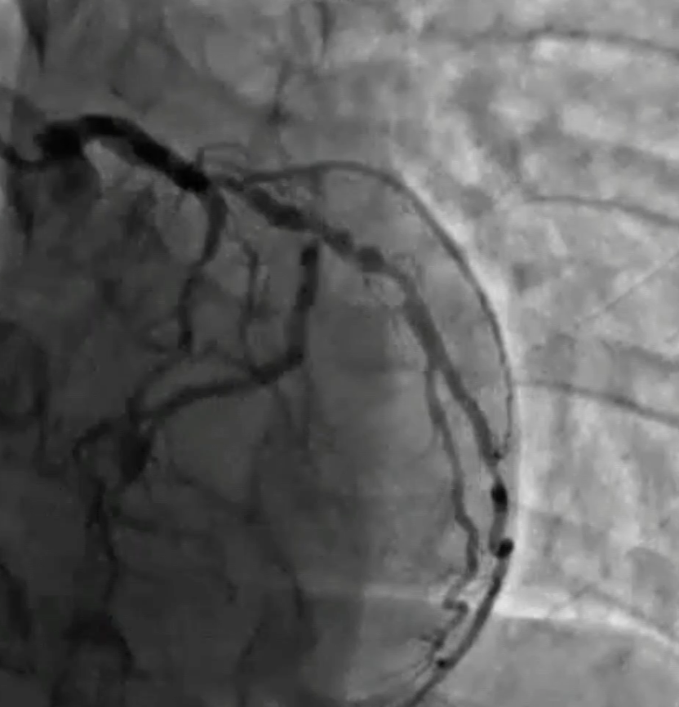
        - Normally LDL is brought in to the cell by LDLR & broken down in liposome & LDLR is recycled, if PCSK is there it will degrade the LDLR, if LDLR is mutated LDL will build up (think of LDL as a high cholesterol waste product of exogenous lipid production)
        - **FH - Familial Hypercholesterolemia** - **autosomal dominant**
          * “homozygous” not actually homozygous, just defects in 2 genes, worse than “heterogenous”
          * Rate: 1:250 - not that rare
          * do “cascade screening” - screen potentially affected relatives
          * mutated genes that cause FH: **LDLR** (brings LDL out of blood), **PCSK9** (PCSK9 degrades LDLR)**, APOB** (APOB100 is receptor for LDLR)
          * average LDL for FH pt. ~ 200 mg/dL
      + **High triglyceride states** - reduced ability to clear TG from blood stream
        - normal triglyceride < 150 mg/dL
        - clinical findings: ↑ TC, ↑↑TG, increased ASCVD risk, xanthomas, pancreatitis
        - Most commonly caused by lifestyle
        - caused by some single gene **autosomal recessive** (LPL, APOC2, APOC5, LMF1, GPIHBP1), usually polygenic inheritance “familial chylomicronemia”
          * Lipoprotein lipase (LDL) usually reduces density of lipid particles (chylomicrons → VLDL → IDL → LDL)
        - clinical findings (if not eating super low-fat diet)
          * eruptive xanthomas 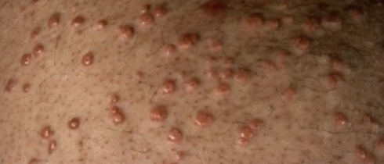
          * pancreatitis (risk w/ TG > 500) leading to DM2 & CVD
      + **Low LDL states** - rare genetic diseases, causing ↓ HLD-C
      + **Combined hyperlipidemia** - most common hyperlipidemia
        - polygenic exacerbated by lifestyle, conveys CVD risk
        - ↑ TC, ↑ LDL-C, ↑ TG, with ↓ HDL-C
    * LDL & Lp(a) are casual for CVD
    * Lp(a) - LDL-like core, apo(b100), apo(a)
      + normal is <30mg/mL elevated is >50mg/dL
      + specifically lowering Lp(a) increases survival from CVD events
      + We don't really know how to lower Lp(a)
22. **Describe the indications for lipid lowering therapy.** 
    * HMG-CoA reductase is the key rate limiting step of cholesterol synthesis
    * Triglyceride synthesis uses a series of enzymatic steps, we don't have any drugs that targets these though
    * Normal values
      + Total-c < 200
      + LDL-c < 100
      + Triglycerides < 150
      + HDL-c > 60
    * Statins are indicated for:
      + *Primary prevention*: FH, diabetes, LDL > 190, high calculated ASCVD risk >7%
        - high risk of ASCVD: family history of premature ASCVD, ↑ LDL-c, CKD, preeclampsia, inflammatory disease, ↑ TG, ↑ Lp(a), etc
      + *Secondary prevention*: history of TIA or MI
    * *High intensity statin therapy* is defined as atorvastatin & rosuvastatin
      + are the strongest statins (up to 50% lower LDL-c)
    * Therapies for high-lipids start with lifestyle changes not drugs
23. **Discuss the mechanisms of action of lipid lowering drugs: HMG-CoA reductase inhibitors, fibric acid derivatives, omega-3 fatty acids, bile acid-binding resins, inhibitors of intestinal sterol adsorption, inhibitors of PCSK9.** 
    * **LDL-c lowering**
      + **Statins** - inhibit cholesterol biosynthesis - analogs of HMG-coA reductase - increase recycling of cholesterol from the bloodstream (reduce circulating LDL, increase LDLRs)
        - not safe in pregnancy
      + **Ezetimibe** -inhibits cholesterol absorption - lipid lowering by ~15%, generic cheaper (*poop out the cholesterol, steatosis*) upregulation of LDLr in liver
      + **PCSK9 inhibitors** - expensive, decrease TG and ASCVD events, ↓ LDL-c by ~50%
        - use to lower LDL in “*very-high risk*” patient with recurrent ASCVD events
      + bile acid binding resins - used in pregnancy, reduces fat breakdown by bile, side effects: constipation diarrhea
    * **Triglyceride lowering:** (*lowering TG is only shown to reduce pancreatitis, but not yet CVD*)
      + start with lifestyle changes ↑ exercise, ↓ carbs
      + if high risk start TG lowering to avoid pancreatitis
        - **“fish oil like drugs” Icosapent ethyl** - omega-3 FA
        - **“fibrates” fenofibrate & gemfibrozil** - fibrinic acid inhibitors - ↓ TG & pancreatitis, no effect on LDL-c or CVD
    * **Lp(a) lowering**: lifestyle changes, no drugs that lower lp(a)
24. **Recognize the efficacy and adverse effects of lipid lowering drugs.** 
    * Statins:
      + side effects - maybe muscle aches
      + adherence to statins increases overall survival - 50% of people do not take their statin 1y after cardiovascular event
25. **Describe the structure of the anterior pituitary; cell types; principal hormones; relationship of anterior pituitary hormones to releasing or inhibiting factors from hypothalamus.** 
    * 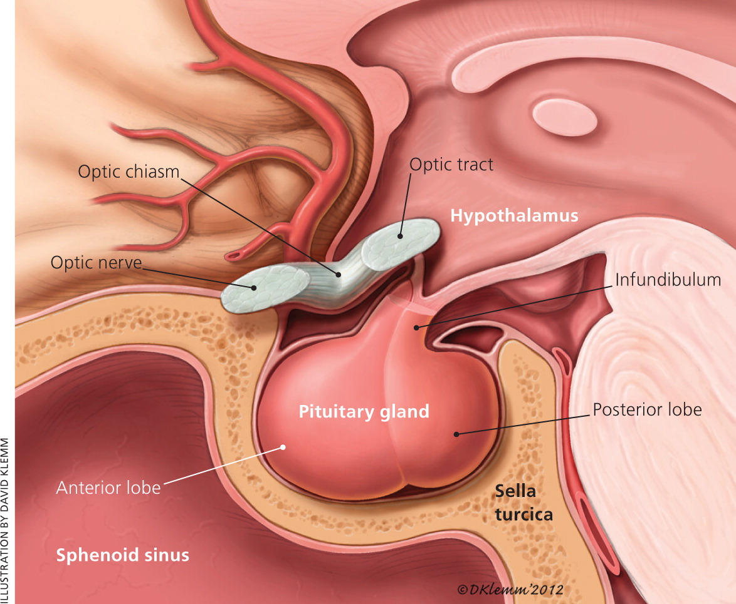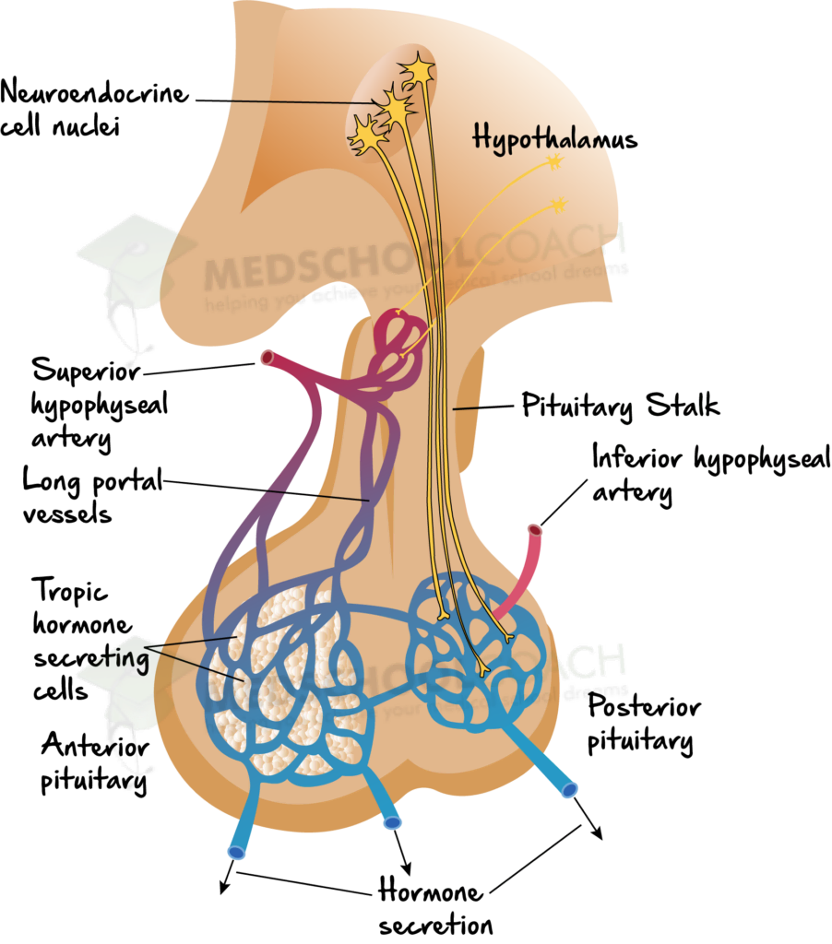
    * Anatomy (best viewed on MRI)
      + The pituitary gland sits in the sella turcica, and is bounded on the sides by the cavernous sinus and superiorly by the optic chiasm.
      + The infundibulum, or pituitary stalk, connects the hypothalamus to the pituitary gland.
      + A tumor of the pituitary gland can compress the optic chiasm, leading to visual field compromise including **temporal hemianopsia** (sorta like tunnel vision)
        - **optic chiasm** is directly above pituitary gland so information that crosses the X will be lost (lateral info)
    * **Posterior pituitary (neurohypophysis):** Large neurons (Magnocellular) that send projections into the neurohypophysis, and then release hormones into the bloodstream: ***ADH & oxytocin***
      + received systemic circulation
    * **Anterior pituitary GLAND (adenohypophysis):** Smaller neurons (Parvicellular) that send axonal projections into the hypothalamus to release the releasing-hormones (*TRH, CRH, somatostatin, GHRH, GnRH, Dopamine*) to trigger the adenohypophysis to release ***FLAT PEG hormones*** into circulation
      + The adenohypophysis is fed by a plexus of portal veins, (think of the ant. pit. like a gland with 2 capillary beds) containing high amounts of hypothalamic hormones directly from the hypothalamus *unlike the posterior pit that receives systemic circulation
      + Cell types: Thyrotrophs (TSH), Corticotrophs (ACTH), Somatotroph (GH) *about 50% of cells*, Lactotroph (prolactin), Gonadotroph (LH, FSH). Somatolactotroph make both prolactin and GH. *All derived from ectoderm from Rathke’s pouch*
26. **Discuss negative and positive feedback and short- and long-term feedback loops.** 
    * “Servomechanisms” of endocrine control
      + (-) Negative feedback loop: X increases secretion of Y
      + (+) Positive feedback loop: X decreases secretion of Y
      + short closed feedback loop: X stimulates secretion of Y, Y turns off secretion of X
        - Example: 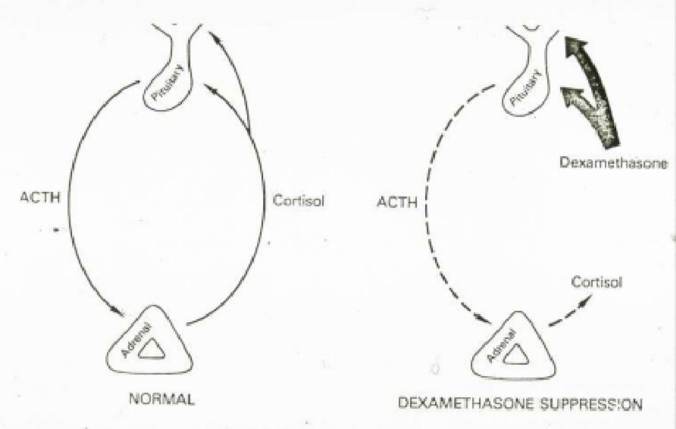 ACTH stimulates adrenal to make cortisol, cortisol turns off ACTH (because cortisol only lasts a few minutes, this will result in a pulsatile cycle of cortisol/adrenal production.)
          * ***dexamethasone suppression -*** *dexamethasone* is a synthetic glucocorticoid agonist - lasts hours in body - turns off cortisol production leading to adrenal insufficiency
      + long closed feedback loop: X stims secretion of Y, Y stims secretion of Z, Z turns off X&Y
        - Example: 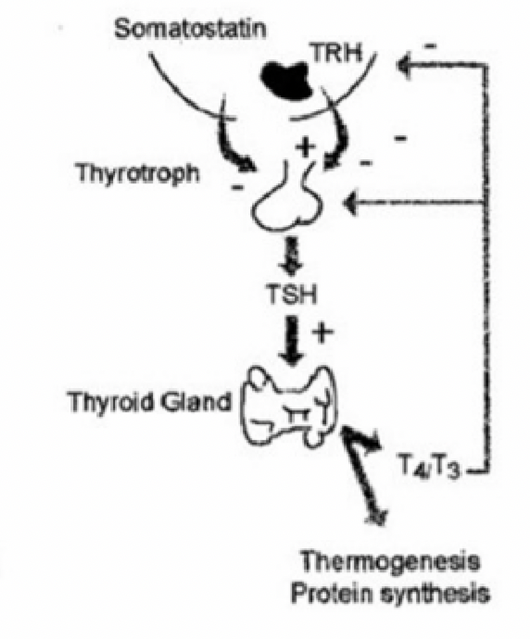TRH stims secretion of TSH which stims secretion of T3/T4 which inhibits TRH and TSH production
27. **Explain what is meant by an endocrine rhythm and be able to describe the diurnal variation of at least one endocrine hormone and state when this rhythm is disrupted.** 
    * different hormones are released in different patterns (daily, hourly, etc) and inappropriate variation throughout the day can be problematic
    * **Examples:**
      + Melatonin peaks at night (sleepytime drug)
      + Cortisol peaks in the morning & is lowest at night
        - cortisol is chronically elevated in depression
        - usually if stressors are chronic, cortisol activation is adjusted so it is not always elevated, may be unable to respond to new stressors
        - some people are more sensitive to stressor
      + leptin peaks around dinner time (satiety hormone)
      + GH is highest at night when sleeping
      + **LH** is secreted mostly at night, varies widely w/ weeks of the menstrual cycle
        - low levels at all times in children, in adulthood remains higher throughout day
        - **Polycystic ovarian syndrome (PCOS**): LH secretion is no longer during sleep, clinical symptoms: obesity, virilization, amenorrhea, insulin resistance
    * Because the body has cyclic endocrine signaling, the timing that we give exogenous hormones will be important to get the desired response
      + Ex: using dexamethasone to inhibit cortisol production is more effective when given right before 8AM (peak cortisol production time), however this does not work in depressed pts who have dysregulated cortisol production
    * repeated stress can disrupt circadian oscillator
28. **Describe the consequences of pituitary tumors synthesizing excess or insufficient**

**hormone(s).**

* + there can be tumors of the pituitary that are “non-functional” that do not produce hormones, the following diseases are from “functional tumors”
  + **Cushing Disease**
    - Causes:
    - Corticotroph cell neoplasm - pituitary tumor producing too much ACTH → **↑↑ cortisol**
    - Neuroendocrine ACTH producing carcinoid (lung) tumor → **↑↑ cortisol**
      * *both are considered *Cushing syndromes*- any disease with high cortisol levels
    - **Signs:** central weight gain, hair loss, diabetes, HTN, easy bruising, weakness, with round face, plethora on cheeks, and fatty neck
    - medicated (left)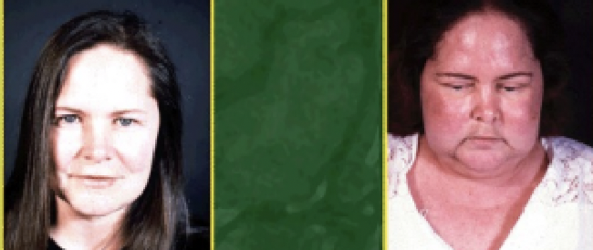active cushing disease (right)
    - High cortisol turns off **CRH** and **ACTH** via negative feedback
    - can be *cyclic Cushing-disease* with periods days to weeks of high release of cortisol, indicated more severe disease

1. **Distinguish primary versus secondary end-organ failure.** 
   * **Adrenal Insufficiency =** low cortisol
     + Flu like symptoms, can progress to shock & coma
     + **Primary Adrenal Insufficiency- “Addison's disease”** 
       - **primary organ failure** because adrenal stops making cortisol
       - body tries to correct low cortisol by ramping up CRH & ACTH
       - **High** ACTH, **high** melanocyte stimulating hormone (MSH) → dark skin, **hyper**kalemia (due to low aldosterone)
     + **Secondary Adrenal Insufficiency**
       - **secondary organ failure** because it is due to low upstream effectors (in this case low ACTH)
       - body will be able to make other mineralocorticoids (aldosterone)
       - **Low** ACTH, **low** melanocyte stimulating hormone (MSH) → paleness, **normo**kalemic (due to normal aldosterone signaling)
       - treated with synthetic corticosteroids such as hydrocortisone or prednisone
   * **Menopause** - is **primary** end organ failure of the ovary - inability to make estrogen regardless of upsteam signalling
     + use elevated FSH levels to diagnose menopause
2. **Understand pulsatile vs. continuous GnRH as an illustration of the importance of hormone pattern to biological effect.** 
   * GnRH neurons are controlled by multiple inputs for secretion, as well as inhibitory feedback from testosterone or estrogen.
   * GnRH stimulates LH and FSH release by the ant. pit. to stimulate testis and ovary function
   * in experimental model, continuous infusion of GnRH was unable to raise LH and FSH levels, but pulsatile infusions were able to boost LH and FSH
   * **Kallman syndrome** (reduced GnRH and lack of puberty) it is critical to use **pulsatile** administration of GnRH agonist to elicit puberty
   * **Hormone sensitive tumors** (Prostate cancer, uterine fibroids) use **continuous** GnRH to abolish testosterone/estrogen
     + also useful for endometriosis, preparation for IVF, precocious puberty
3. **Describe the properties of GH-IGF1 and the hypothalamic-pituitary-end organ regulation.** 
   * Hypothalamus secretes **GHRH** → stimulates ant. pituitary to release **GH** → Circulating GH stimulates production of **IGF1** in several organs (liver, kidneys, bone) → free IGF1 inhibits hypothalamus & ant pit production of growth axis
     + liver is the major source of circulating IGF1
     + most IGF1 is bound to other proteins (IGFBP3 & ALS)
     + GH is a protein - cannot give orally because will be metabolized in stomach
     + IGF1 is structurally similar to proinsulin - *IGF1 & insulin can act on each others receptors*
       - IGF2 is similar to relaxin
4. **Describe the metabolic effects of GH and the importance of GH for growth in children.** 
   * GH secretion cycle is different across sexes and age groups (males release more at night, older people release less overall) *\*GH & IGF1 are highest in youth\**
   * GH signals for IGF1 production, cell proliferation (via JAK2/PI3K path), glucose metabolism
     + GH is mostly an *anabolic hormone* but also has lipolytic function
   * **GH deficiency (GHD)** 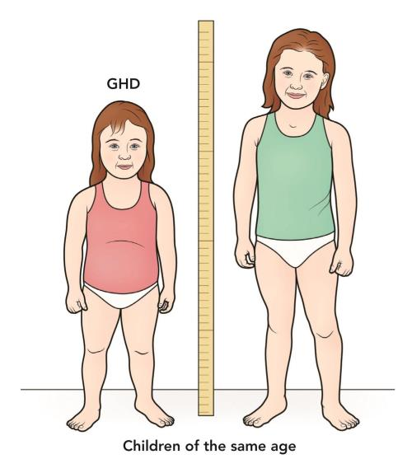
     + onset in children will result in short stature, central obesity, prone to hypoglycemia
     + onset in adulthood (pit tumors, damage to pit, etc) will result in ↓ bone density, ↑ LDL-c, ↓ lean body mass, weak muscles, poor aerobic capacity
       - height does not change because growth plates closed
     + GH treatment (parenterally not oral) ↑bone mass, ↑height, ↓ visceral fat, ↑ muscle
       - in children with GHD treatment goal is ↑ height “catch up growth”
       - in adults with GHD treatment goal is ↓ visceral fat ↑ bone density ↑ muscle
       - increased vascular related mortality after GH replacement
       - Other indications of GH therapy: Turner syndrome, Prader-Willi syndrome, idiopathic shortness
       - GH therapy is expensive $$$
     + *if GH receptor defect* need to give IGF1 to stimulate downstream effects of GH
5. **Describe the consequences of pituitary tumors synthesizing excess or insufficient hormone(s).** 
   * Somatotrophs make GH
   * **Gigantism**: Excess GH in childhood (aka open growth plates)
   * **Acromegaly**: Excess GH in adulthood (aka closed growth plates) MEN-1 mutation
   * 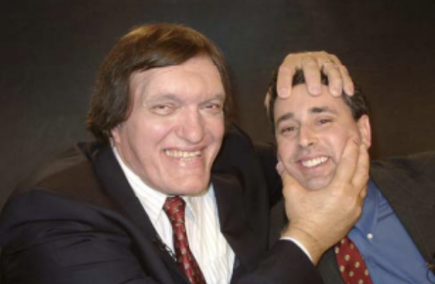
   * Robert Wadlow had **X-linked acrogigantism**: duplication of GPR101 gene → early onset GH excess → early mortality
   * 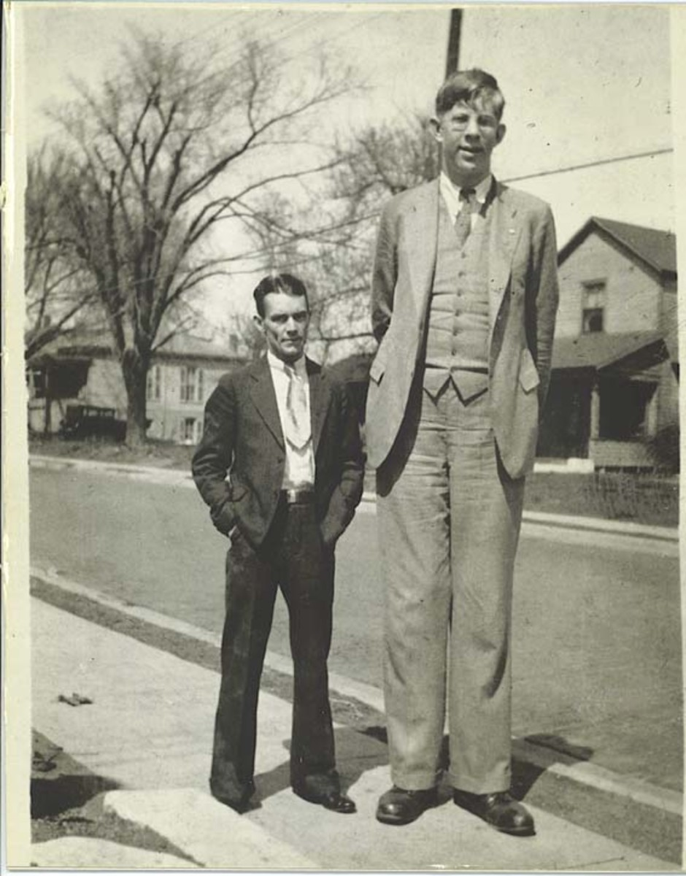*ex of both acro & gigantism*
   * **Consequences of too much GH:** heart disease, arthritis, sleep apnea, diabetes,neuropathy, scoliosis
   * **Treatment**: surgery/cyberknife radiation to reduce tumor, somatostatin analogs, GH antagonists, dopamine antagonist (mechanism not understood)
6. **Describe how prolactin secretion is regulated.** 
   * lactotroph cells make prolactin, prolactin is stored in anterior pituitary, effect of prolactin is milk production in breast
   * prolactin is constitutively made, under tonic inhibitory control by dopamine
7. **Describe physiologic and pathologic causes of hyperprolactinemia.** 
   * **Hyperprolactinemia:**
     + induced physiologically by suckling, oxytocin (pregnancy, intercourse), sleep, stress
       - prolactin is mostly secreted at night and around meals (& when holding baby)
     + induced pathologically by:
       - prolactinoma (benign lactotroph cell tumor)
       - damage/compression of pituitary stalk will cause (because decreased negative inhibition of dopamine from hypothalamus)
       - pharmacologic: risperidol (antipsychotic)
8. **Describe the clinical features and treatments of prolactinemias.** 
   * Prolactin → anti-gonadotropic effects at all levels of hypothalamic pituitary (turns off GnRH, LH, FSH) → amenorrhea when nursing
   * **Clinical features of prolactinemia:** in men - impotence, in women - galactorrhea/amenorrhea & infertility in childbearing years, in children - delayed puberty
     + *most side effects are due to suppression of GnRH pathway
   * **Treatment**: dopamine agonist (bromocriptine, cabergoline) inhibits prolactin
9. **Describe the tempo of, and hormones regulating, normal growth and puberty and the factors to consider if growth is normal, too fast, or too slow.** 
   * Growth is regulated by many things: genetics, nutrition, hormones (IGF, insulin, T3/T4, corticosteroids, estrogen/testosterone), psychosocial factors, etc
   * Most growth happens early in life, with final push at puberty (when growth plates close)
   * We can detect progression of puberty with tanner staging (the development of secondary sex characteristics indicates puberty is underway and this is the final push in growth)
     + **Puberty in Females**: Breast bud at 10, Pubic hair soon after, Menarche at 12.7, Growth spurt early in puberty
     + **Puberty in Males**: Testes start to enlarge at 11.5, Pubic hair 1-2 yrs later, Testes mature at 15, Growth spurt later in puberty
     + 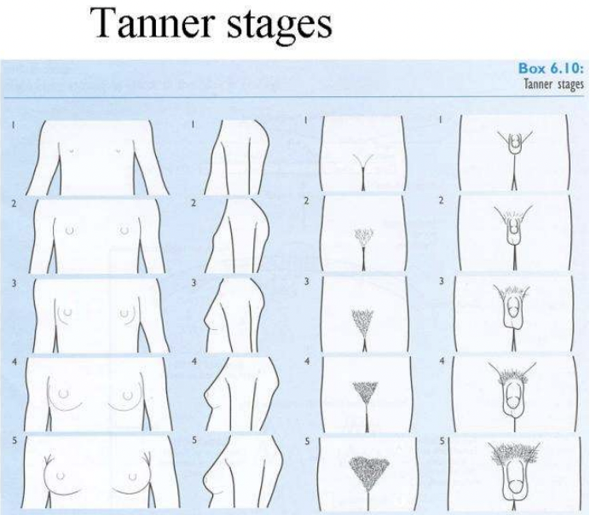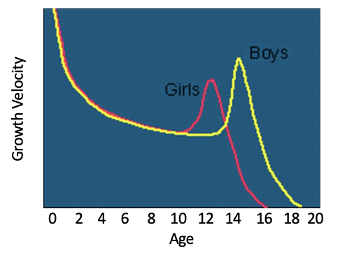
10. **Distinguish normal variant growth patterns (constitutional delay of growth and puberty, genetic short stature) from the endocrine disorders (GH deficiency and resistance, Hypothyroidism, Cushing’s syndrome, Precocious puberty).** 
    * normal growth patterns are usually **proportional** and **similar to the parents**
      + midparental height: for female: (Hmom + Adad - 5”) for male (Hmom + Adad + 5”)
    * slight different in puberty timing in difference races
    * “crossing percentiles” is a sign that something is wrong
    * 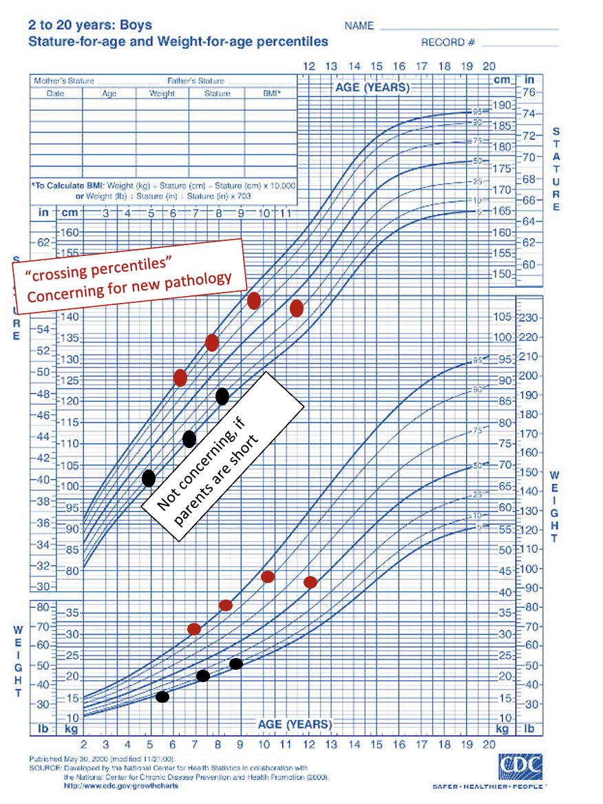
    * Birth weight/length does not predict adult height (*can start predicting height at 2y)*
      + **Small fetal size**: indication of placental insufficiency, expect “catch up” growth
      + **Macrosomy (large fetal size)**: can be caused by maternal diabetes (rember baby makes its own insulin), expect “catch down” growth
    * **Constitutional delay of growth and puberty** “late bloomers”
      + may be genetic, ask if parents had puberty late
      + check growth plates & Tanner stage to determine if puberty has begun
    * **Achondroplasia & Hypoplasia**
      + disproportionate short stature - long bones are short
    * **Turner syndrome** 
      + can present with many symptoms (webbed neck, cardiac abnormalities, etc), but always presents with short stature
    * **Hypothyroidism:**
      + **Signs**: growth failure, puberty - delayed, rarely precocious, constipation, dry skin, weight gain, bradycardia, fatigue, feeling cold
      + **Treatment**: Thyroxine *must be given before growth plates close to avoid incomplete catch up
    * **Growth hormone deficiency**: see previous lecture
    * **Glucocorticoid excess:** 
      + **signs:** increased weight, slowed height
    * **Tall Without Accelerated Growth**: Familial (genetic) tall stature
      + **Marfan syndrome**: autosomal dominant, tall stature, aortic abnormalities
      + Klinefelter syndrome, Homocystinuria
    * **Tall with accelerated growth:**
      + Exogenous obesity(will result in normal height)
      + **Precocious puberty** : early puberty, accelerated growth before normal time of puberty, closes growth plates too early → short stature
      + also Congenital adrenal hyperplasia, Hyperthyroidism, GH excess – RARE, Cerebral gigantism
11. **Understand which lab studies might be used to distinguish different growth disorders.** 
    * Medical History: birth weight/length, growth rates over time, illness & meds (cancer)
    * Family history: parental height, parental timing of puberty
      + *\*\*\*do not just make race based assumptions about height\*\*\**
    * Physical Exam: height, weight, growth trends, Tanner puberty stage
    * Check serum hormone levels:
      + T4, TSH, etc
      + IGF-1 & IGF bp3 (GH is secreted in pulses and mostly at night so we don't measure it)
      + sex steroids
      + rarely cortisol (if nothing else shows up, look for excess cortisol)
    * Nonendocrine screen: CBC, ESR, celiac screen, renal & hepatic function, karyotype
12. **Understand the prevalence of obesity in the U.S. and disparities based on race/ethnicity, education level, and income.** 
    * ⅓ of US adults are overweight (BMI 25-30)
    * 41.9% of US adults are obese (BMI >30)
      + increased rates in low SES & minority populations
    * due to large portion sizes and processed high calorie foods and sedentary lifestyle
13. **Understand some health consequences of obesity.** 
    * Obesity causes inflammation & disease:
      + ASCVD, hypertension, dyslipidemia, T2D, arthritis, cancer, asthma
      + Strong correlation between obesity & T2D
14. **Describe how much weight loss is needed to decrease obesity-associated comorbidities.** 
    * modest reduction in weight (4-7%) resulted in dramatic (58%) reduction in prediabetes→T2D
    * NIH weight loss goal for overweight/obese: lose 10% of body weight
15. **Appreciate results achieved from medical approaches to obesity management.** 
    * lifestyle changes usually only lose <5% wt
      + Thiazolidinediones in many pathways
      + losing weight makes you more hungry
    * Bupropion is a norepinephrine reuptake inhibitor (NE inhibits feeding) + Naltrexone is an antagonist to the opiate receptor (promotes hunger)
      + 6% wt loss at 1yr
    * Phentermine + Topiramate (mediates appetite & satiety)
      + 10% wt loss at 1 yr
    * Liraglutide or Semaglutide: Glucagon-like peptide-1 (GLP-1) receptor agonist
      + 15% wt loss at 1 yr
    * Tirzepatide (targets incretins in gut, GIP & GLP-1)
      + 20% wt loss at 1yr
16. 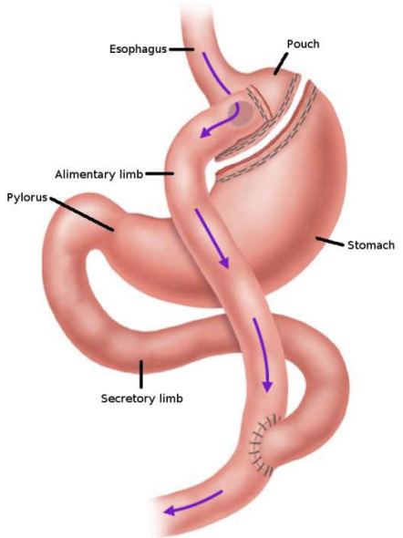**Appreciate results achieved from surgical approaches to obesity management.** 
    * **Barrier Methods**: block absorption in stomach & stimulate satiety
    * **Roux-en-Y Gastric bypass surgery**: limit absorption in stomach, stimulate fullness
      + 30% wt loss at 1 yr
17. **Understand the “treatment gap” in the management of obesity and how healthcare providers can close it.** 
    * there are not therapies for moderate weight loss (7-15% body wt)
18. **Understand the epidemiology and pathophysiology of pancreatitis.** 
    * Pancreatitis : inflammation/destruction of the pancreas
    * causes of pancreatitis:
      + EtOH
      + cholethiasis (gallstones)
      + anatomical abnormalities
      + autoimmune
      + idiopathic
    * Symptoms:
      + epigastric pain, malnutrition, opioid addiction, depression, steatosis
    * Having one pancreatitis attack puts you at higher risk for future attacks
    * higher risk of pancreatic cancer
    * Diabetes with pancreatitis increases risk of all comorbidities
19. **Recall the indications for pancreatic transplantation.** 
    * Patients with insulin dependant diabetes who also:
      + need a kidney transplant (end stage renal disease)
        - gets simultaneous kidney pancreas, or sequential
      + OR have poor glucose control despite best medical therapy
        - requires hypoglycemic unawareness
      + OR are emotionally adversely affected by diabetes
    * Rare indications:
      + insulin allergies
    * The transplant surgery is complicated (take duodenum and blood supply of panc from deceased donor, put on ilium of recipient) *don't take out old pancreas
20. **Understand the potential complications of pancreatic transplantation.** 
    * complications: clotting, rejection, pancreatitis
21. **Recall the indications for islet transplantation.** 
    * Islet transplantation requires taking out old pancreas and injecting new islets (can be autologous transplant)
    * Indications:
      + chronic pancreatitis, history of recurrent acute pancreatitis, hereditary pancreatitis
      + narcotic dependent/pain impairing quality of life
      + failure to respond to maximal medical therapy
      + adequate islet cell function (non-diabeteic or C-peptide positive)
22. **Discuss the long-term outcomes of islet transplantation.** 
    * Quality of life: improved 10y later
    * Pain relief: usually less pain long-term
    * reduced hypoglycemic episodes, improves survival for pt with diabetes
23. **Appreciate the technological challenges of insulin delivery** 
    * Old technology: finger stick glucose meter and insulin injections
    * Current technology: continuous glucose monitor (CGM), with closed-loop insulin pump
      + **Obstacles:**
      + long time to action of insulin: difficult to provide real time adjustments because even the fastest glucose takes ~40 min to act and ~2 hrs to go away
      + scary side effects: hypoglycemia/hyperglycemia
      + mistrust of estimated glucose values: subcutaneous detection of glucose with a CGM can introduce measurement error
24. **Contrast commercial and open source automated insulin delivery systems** 
    * each component (CGM, ACE insulin pump) of the delivery systems are highly protected IP
      + expensive
    * Some open source devices have been devised
      + unregulated, but allows for other users to optimize

**______________________________MIDTERM________________________________**